pytorch imagenet预训练分类模型预测推理

infer_cls_torch_imagenet
fun:
imagenet预训练分类模型预测推理
env:
numpy==1.19.5 scikit-learn==0.24.2
opencv-python==4.5.1.48 Pillow8.2.0
tensorflow-gpu==1.14.0 Keras==2.2.5
torch==1.4.0 torchvision==0.5.0
ref:
https://www.cnblogs.com/vvzhang/p/14116632.html
文件：
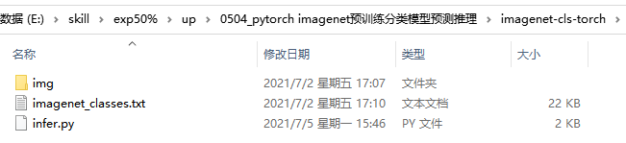
代码：
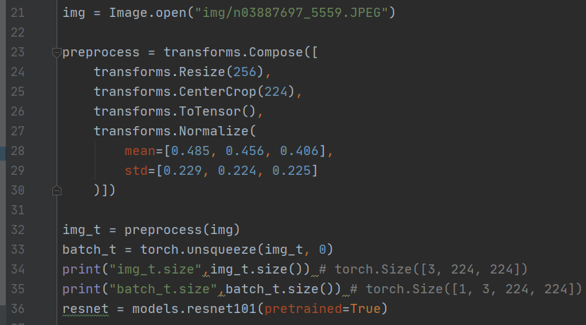
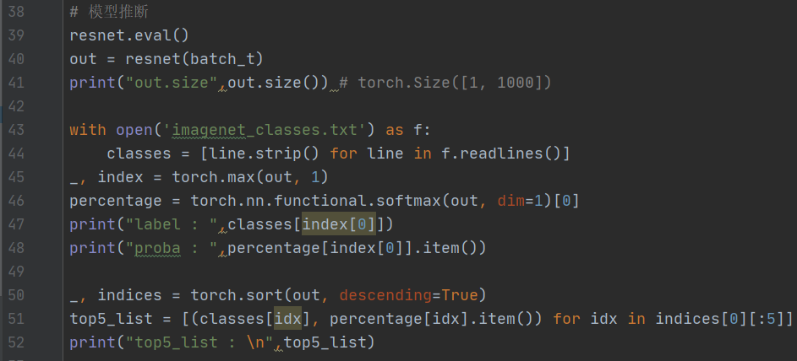
手动下载预训练模型并拷贝到指定路径
Downloading: "https://download.pytorch.org/models/resnet101-5d3b4d8f.pth" to /root/.cache/torch/checkpoints/resnet101-5d3b4d8f.pth

